**Open GitHub's oauth app creation page**

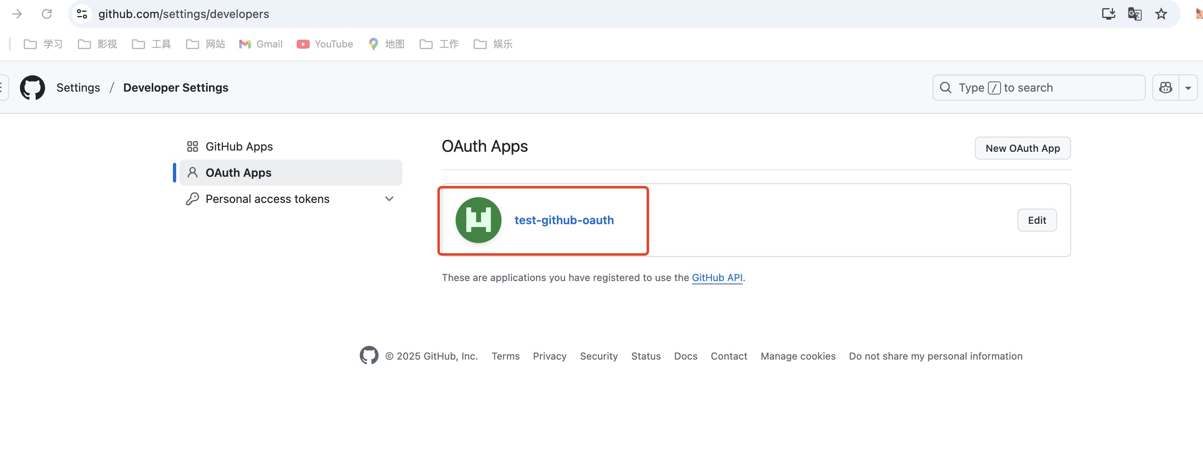

**Enter the app you want to use**

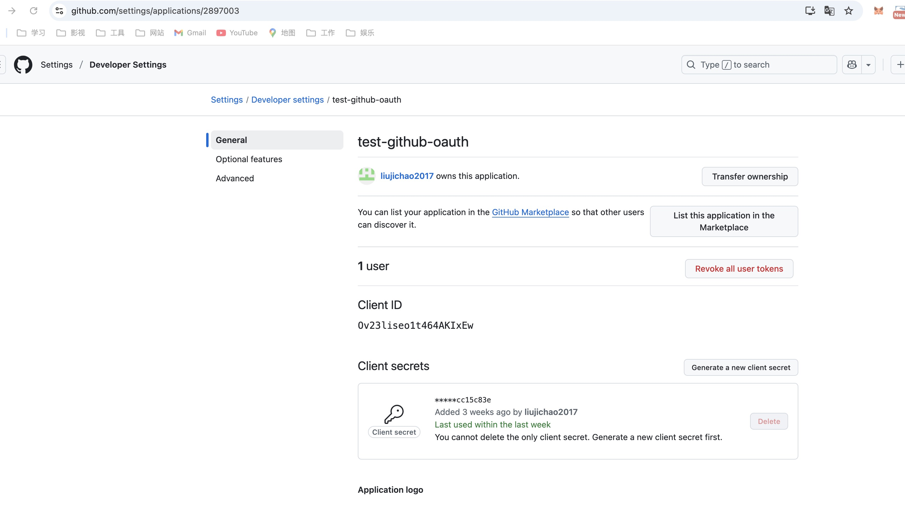

**Set your project address and callback address, make sure to keep it consistent with the actual project**

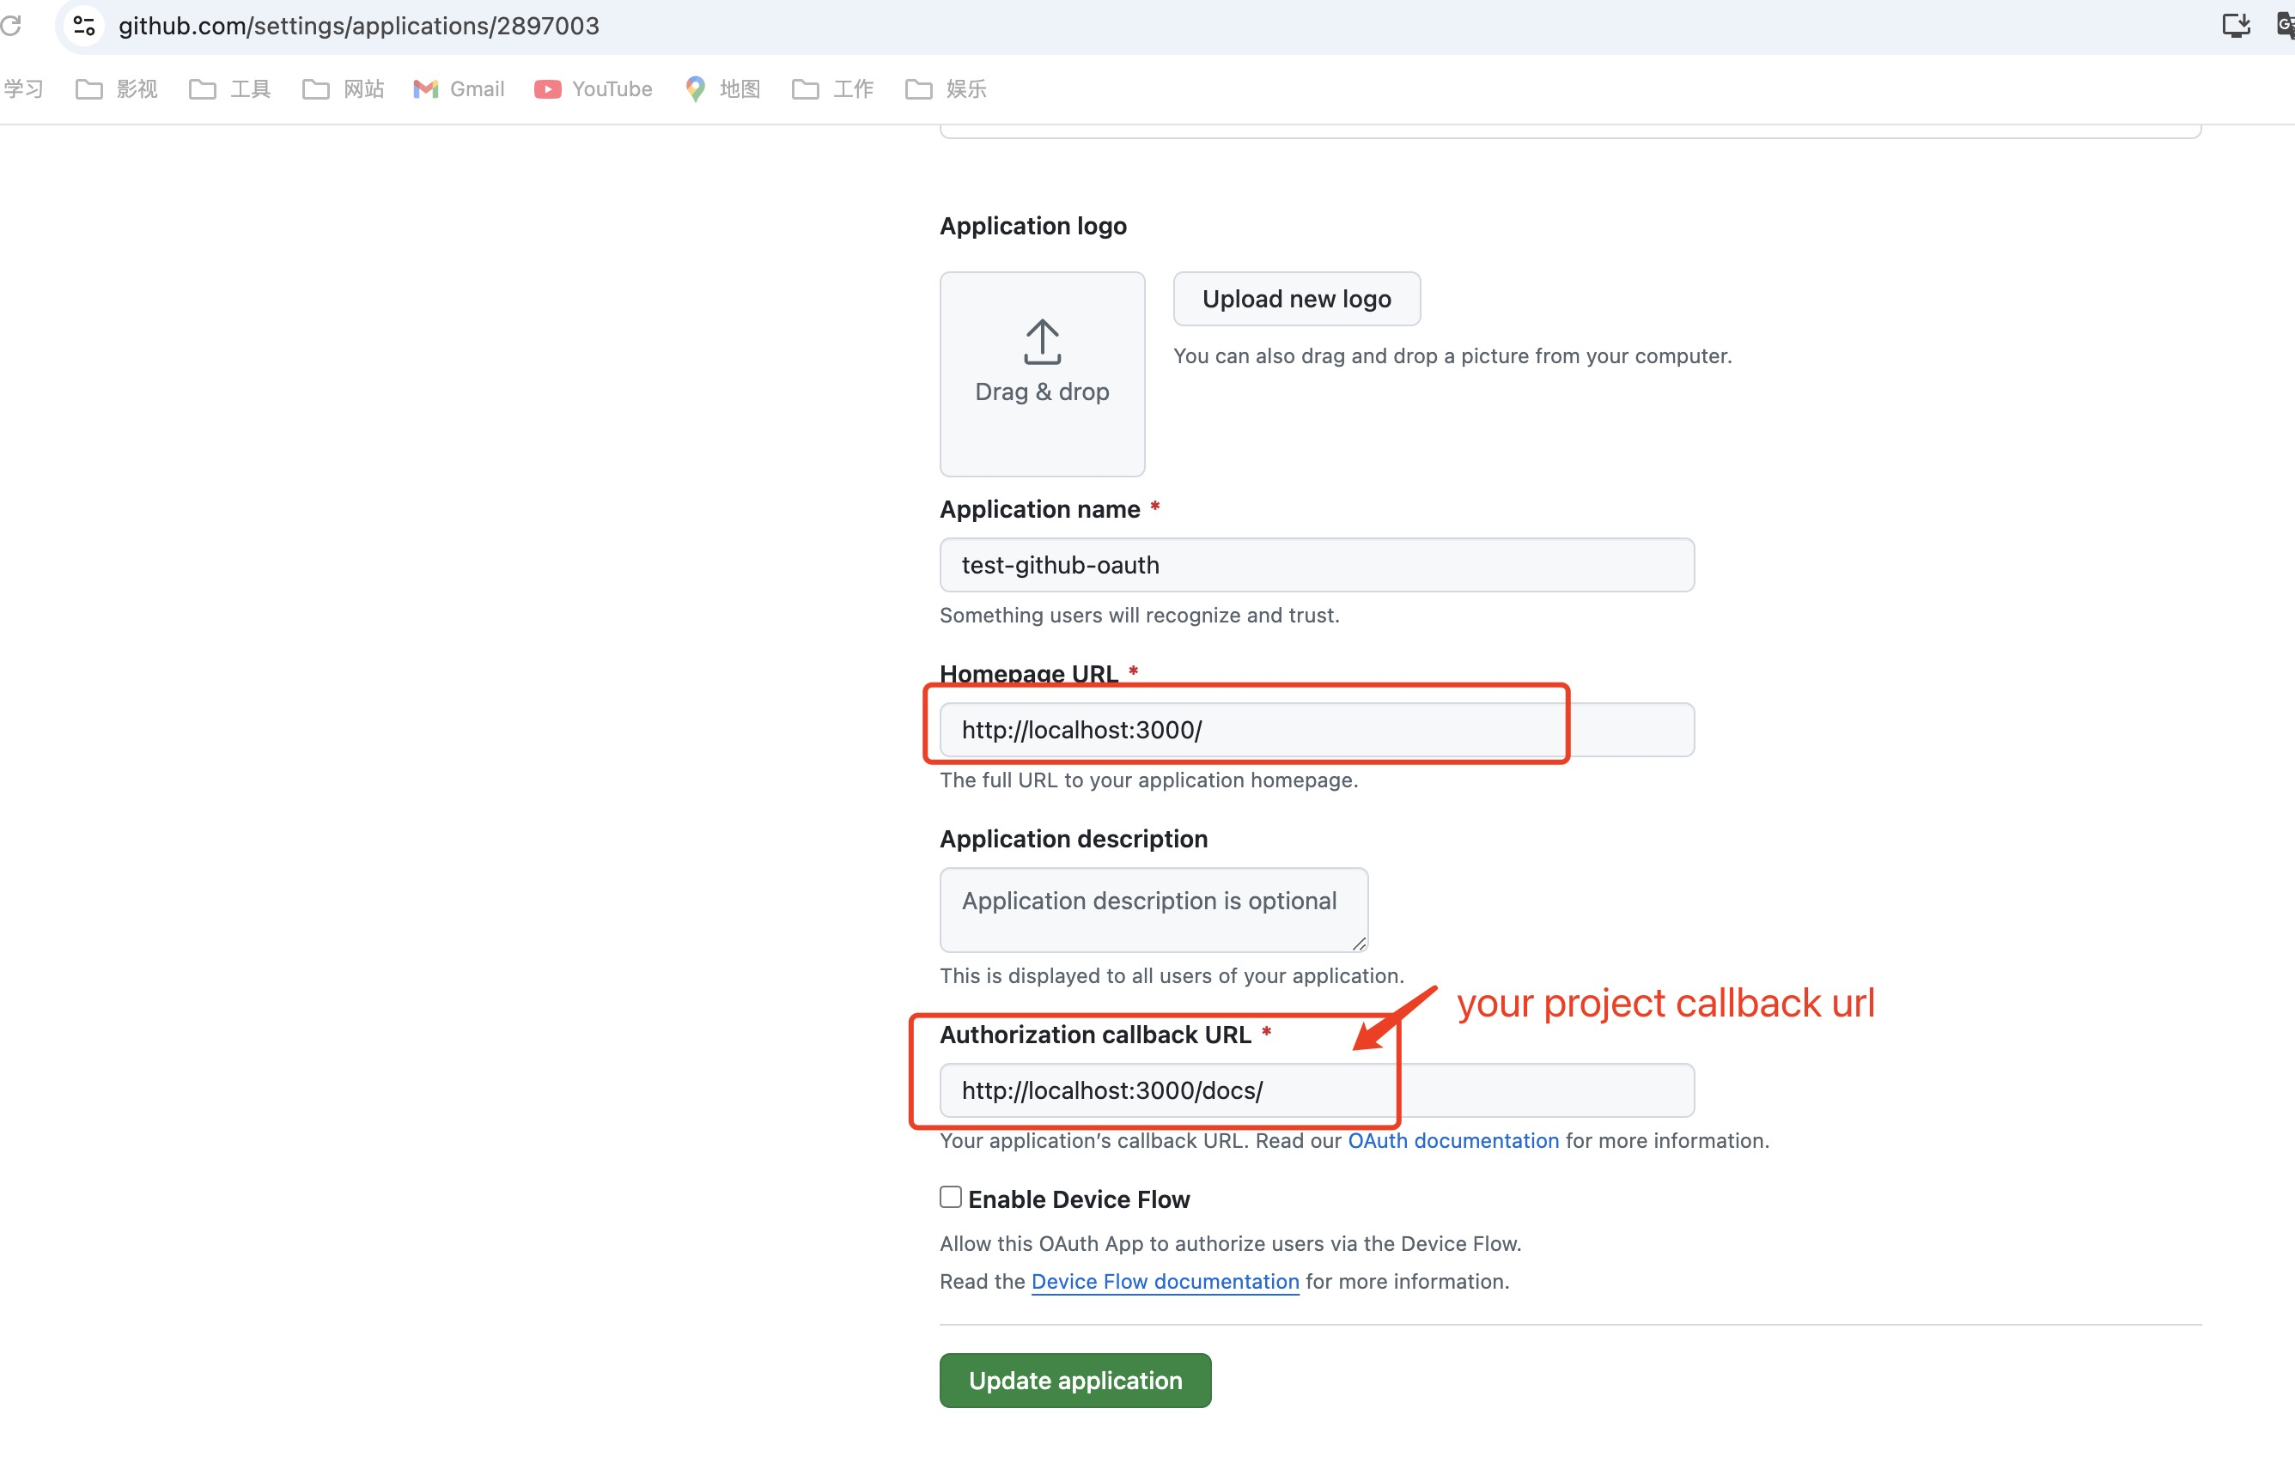

**Add this information to your project's .env file**

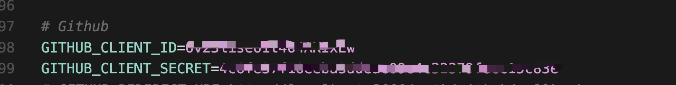

**You can apply for GitHub user authorization in the code and create a repository**